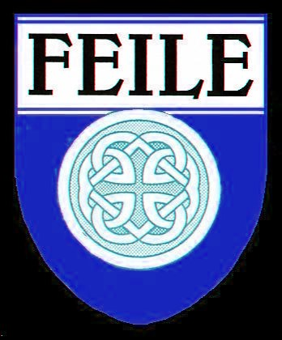
2023 FEILE SCHOLARSHIPS
Joe Moran Memorial Scholarship

Up to three scholarships of $2,000 each
will be awarded to high school seniors
who will be entering accredited institutions of higher learning in 2023.
Applicants need not be of Irish heritage to participate.
Awards will be based primarily on the submission of
an essay with additional consideration for school, community, church activities as well as overall academic achievement.
The completed application form should be submitted along with the essay by

May 1, 2023
Scholarship award winners will be notified in June 2023
Complete details, instructions, application and essay requirements are included at
http://feileinc.org/scholarships
Questions: FeileInc89@gmail.com
TOPIC:
With a coastline of almost 5000 miles Ireland encompasses fertile interior plains ringed by mountains. It is close, yet far. Accessible, but not in the farthest reaches. It's part of Europe, but not totally. How did the geography of Ireland determine and influence it's history, culture and story?

Feile, Inc., of Fairfield, CT, is a non-profit organization dedicated to the promotion of Irish culture.

